
H
CATHOLIC JUNIOR COLLEGE
Preliminary Examination 2009
Higher 2

CHEMISTRY 9746/01

Paper 1 Multiple Choice
17 September 2009

1 hour

Additional Materials: Multiple Choice Answer Sheet
Data Booklet

READ THESE INSTRUCTIONS FIRST

Write in soft pencil.
Do not use correction fluid.
Write your name and class on the MCQ Answer Sheet in the spaces provided.

There are forty questions on this paper. Answer all questions. For each question there are four possible answers A, B, C and D.
Choose the one you consider correct and record your choice in soft pencil on the separate Answer sheet.

Read the instructions on the MCQ Answer Sheet very carefully.

Each correct answer will score one mark. A mark will not be deducted for a wrong answer.
Any rough working should be done in this booklet.

This document consists of 13 printed pages and 1 blank page.



CJC Chemistry Department

© CJC 2009

For each question there are four possible answers, A, B, C and D. Choose the one you consider to be correct and record your choice in soft pencil on the separate answer sheet provided.

1 Which statement about one mole of a gas is always true?

A It has the same mass as one mole of hydrogen gas.
B It contains the same number of particles as ¹/₁₂ mole of ¹²C
C It occupies the same volume as one mole of ethane gas under the same conditions.
D It undergoes a redox process involving transfer of one mole of electrons.

2 The following diagram illustrates the variation of a physical property with increasing atomic number across a certain Period.
atomic no.

Which of the following is the physical property shown?

A atomic radius B melting point
C first ionisation energy D electrical conductivity

3 Which of the following is not a disproportionation reaction?

A Cu₂O(s) + H₂SO₄(aq) → Cu(s) + CuSO₄(aq) + H₂O(l)
B 2 NaOH(aq) + Cl₂(aq) → NaCl(aq) + NaClO(aq)
C 2 H₂S(g) + SO₂(g) → 3 S(s) + 2 H₂O(g)
D 2 H₂O₂(aq) → 2 H₂O(l) + O₂(g)

4 25.0 cm³ of a 0.0200 mol dm⁻³ solution of a compound of element D is reduced by reaction with Sn, which is oxidised to Sn²⁺ in the process. If the resulting solution required 10.0 cm³ of 0.0200 mol dm⁻³ of acidified KMnO₄ to oxidise D back to its original oxidation state, what is the mass of tin required in the first reaction?

A 0.0100 g
B 0.0238 g
C 0.0357 g
D 0.0595 g
5 Chlorine has two isotopes, ³⁵Cl and ³⁷Cl. In an experiment, a sample of chlorine was vapourised and ionised at high temperatures and passed through an electric field.

The following sets of deflections were observed.
source
-
+
Set I Set II

Which of the species could have produced the series of lines in set I?

A ³⁵Cl⁺, ³⁷Cl⁺
B ³⁵Cl⁺, ³⁷Cl₂⁺
C ³⁷Cl⁺, ³⁷Cl₂⁺
D ³⁵Cl₂⁺, ³⁵Cl³⁷Cl⁺, ³⁷Cl₂⁺

6 Which of the following sets consists of two ionic compounds and one simple covalent compound?

A MgO, Al₂O₃, SiC
B AlCl₃, PCl₅, P₄O₁₀
C Na₂O, AlF₃, SO₃
D BaO, SiO₂, SiCl₄

7 Which of the following pairs does species I have a smaller bond angle than species II?

I II
A NO₂⁻ NO₃⁻
B CS₂ SO₄²⁻
C PH₄⁺ SF₆
D AsCl₃ ClO₂⁻

8 Dinitrogen oxide, N=N=O, burns in ethyne, C₂H₂, in the gaseous phase to produce water vapour, carbon dioxide and nitrogen gases as the only products.
5 N₂O(g) + C₂H₂(g) → H₂O(g) + 2 CO₂(g) + 5 N₂(g) ΔH = -1668 kJ mol⁻¹
Assuming N=N bond energy in dinitrogen oxide is +418 kJ mol⁻¹, what is the nitrogen-oxygen bond energy in dinitrogen oxide in kJ mol⁻¹?

A 382 B 594 C 686 D 1350

9 In oil refineries, an important process is the recovery of any sulfur from petroleum.
2 H₂S(g) + O₂(g) → 2 H₂O(g) + 2 S(s)
The enthalpy changes of formation of H₂S(g) is -20.5 kJ mol^{─1} and that of H₂O(g) is
-243 kJ mol^{─1}.

Which statement is true?

A The above reaction is thermodynamically feasible only at low temperatures.
B Enthalpy change of combustion of H₂S is -445 kJ mol⁻¹.
C The enthalpy change of vapourisation of H₂O is less endothermic than that of H₂S.
D The bond angle for H-S-H is larger than that of H-O-H.

10 Which one of the following statements about the properties of graphite is incorrect?

A It can be used as a lubricant because of the weak force of attraction between layers.
B Each carbon atom is sp² hybridised.
C It is a good conductor of electricity in the direction parallel to the planes containing hexagonal rings of carbon but a poor conductor perpendicular to these planes.
D Carbon to carbon distances between the planes of hexagonal rings is the same as that of carbon to carbon distances within those planes.

11 0.1 g of dry hydrogen gas was placed in a closed 2 m³ vessel with 3.2 g of oxygen gas. The gases were exploded and the system was allowed to cool to 25 °C.
What will be the pressure, in Pa, of the gas left in the vessel after the reaction?
(The volume and vapour pressure of water may be neglected )

A 56.7 B 61.9 C 92.9 D 123.8

12 When 0.20 mol of hydrogen gas and 0.15 mol of iodine gas are heated at 723 K until equilibrium is established, the equilibrium mixture is found to contain 0.26 mol of hydrogen iodide. The equation for the reaction is as follows.
H₂(g) + I₂(g) 2 HI(g)
What is the correct expression for the equilibrium constant, K_{c}?

A 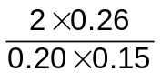 B 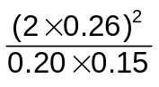
C 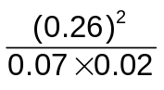 D 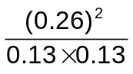

13 Use of the Data Booklet is relevant to this question.
Many laboratory spatulas are made of nickel. Which aqueous solution might react with a nickel spatula?

A Cu²⁺(aq) B Co²⁺(aq) C Mn²⁺(aq) D Fe²⁺(aq)
14 When a quantity of electricity was passed through molten scandium oxide, 5.00 g of scandium and 2.67 g of oxygen were produced at the electrodes. What is the formula of scandium oxide?

A ScO₃ B ScO C Sc₂O₃ D Sc₃O₂

15 The diagram shows the Boltzmann distribution of the speeds of the molecules of a gas.
Point X represents the most probable speed.
If the gas is cooled, in which direction does X move?

proportion of molecules
speed
X
D
C
B
A

16 When 0.010 mol of an unknown compound was completely dissolved in 1.0 mol dm⁻³ of water, the resulting solution was found to have a pH of 4.0. What is the identity of this compound?

A HI B NaOH
C CH₃CH₂NH₂ D ClCH₂CO₂H

17 Which graph correctly describes a trend found in Group VII?

A B
X–X bond energy
Cl₂
Br₂
I₂
boiling point of X₂
Cl₂
Br₂
I₂
X–X bond length
Cl₂
Br₂
I₂
strength of intermolecular forces
Cl₂
Br₂
I₂

C D

18 M is a transition metal. In aqueous solution, it forms the complex ion, [M(H₂O)₆]³⁺.
On oxidation of [M(H₂O)₆]³⁺ to [M(H₂O)₆]⁴⁺, the solution turned colourless. Which of the following is the electronic configuration of the transition metal M?

A [Ar] 3d¹ 4s² B [Ar] 3d² 4s²
C [Ar] 3d³ 4s² D [Ar] 3d¹⁰ 4s²

19 Athletes preparing for the Youth Olympics Games (YOG) in 2010 follow a high-carbohydrate diet to maintain high-intensity exercise for a longer period.
Glucose is an important carbohydrate in biology as the living cell uses it as a source of energy and metabolic intermediate.

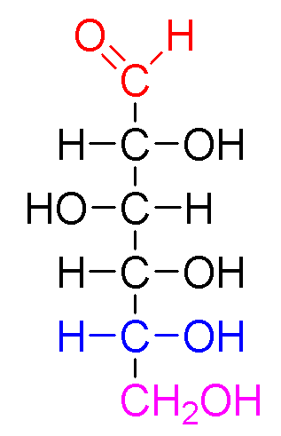
glucose

How many stereoisomers does glucose exhibit?

A 2¹ B 2² C 2³ D 2⁴

20 The equation below represents the sulfonation of benzene under suitable conditions.
+ H₂SO₄ → + H₂O
SO₃H

What is the role of concentrated sulfuric acid in the reaction?

A a dehydrating agent B an electrophilic agent
C a nucleophilic agent D an oxidising agent

21 Chlorofluorocarbons, commonly known as CFCs, undergo homolytic fission by ultraviolet irradiation in the stratosphere. Which radical could result from this irradiation of CHFClCF₂Cl?
•
A CHFClCFCl
B •CHClCF₂Cl
C •CHFCF₂Cl
D •CFClCF₂Cl

22 A product P, isolated from a naturally-occurring source, has a molecular formula of C₉H₁₁NO₃. It possesses a chiral centre and it forms a zwitterion. What could the structure of P be?

O₂N
CH₂CH(OH)CH₃
HO
CH₂CH(NH₂)CO₂H
A B

HO₂C
CH₂CH₂NH₂
CH₃
CH₂CO₂H
C D

23 Which of the following compounds is not an addition product of the reaction between ethene with aqueous chlorine in the presence of sodium bromide?
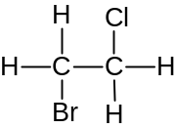
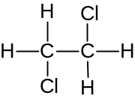

A B
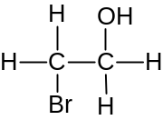
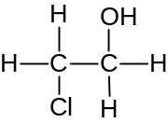

C D

24 Which of the following compounds could be prepared by reacting chloropropane with potassium cyanide and then reducing the product?

A CH₃CH₂CH₃
B CH₃CH₂CH₂NH₂
C CH₃CH₂CH₂CH₃
D CH₃CH₂CH₂CH₂NH₂

25 In the preparation of ethene, ethanol is added a drop at a time to heated reagent Y. The impure ethene is washed by being bubbled through a solution Z and then collected.

What are the reagent Y and solution Z likely to be?

 | reagent Y | solution Z
A | acidified K₂Cr₂O₇ | dilute NaOH
B | acidified K₂Cr₂O₇ | dilute H₂SO₄
C | concentrated H₂SO₄ | dilute NaOH
D | concentrated H₂SO₄ | dilute H₂SO₄

26 The following reaction scheme shows the formation of compound C.
heat

NCCH₂CHClCH₂
CH₂CONH₂
Cl

B
C
1. H⁺(aq)
NaOH(aq)
2. PCl₅

What is the structure of compound C?
NCCH₂CH(OH)CH₂
CH₂COCl
Cl

A

NCCH₂CHClCH₂
CH₂CONH₂
OH

B

ClOCCH₂CHClCH₂
CH₂COCl
Cl

C

ClOCCH₂CH(OH)CH₂
CH₂CONH₂
OH

D

27 Which of the following reagents will give similar results for both butanone and ethanol?

A acidified aqueous potassium dichromate(VI)
B iodine and aqueous potassium hydroxide
C Fehling’s solution
D 2,4-dinitrophenylhydrazine reagent

28 Which of the following reagents is least likely to react with vitamin C?
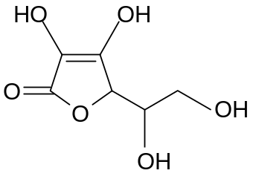

Vitamin C

A 2,4-DNPH
B Na metal
C SOCl₂
D Br₂(aq)
29 Which of the following could be a correct synthesis of aspirin, as shown below?

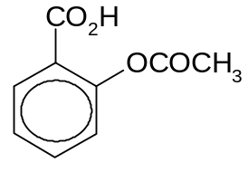
aspirin

A
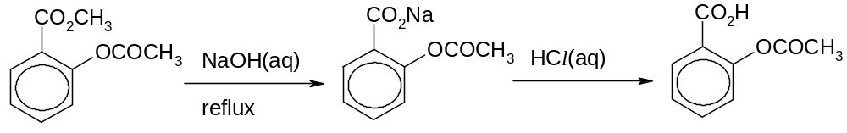

B
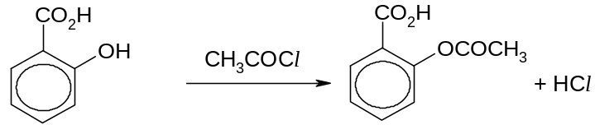

C
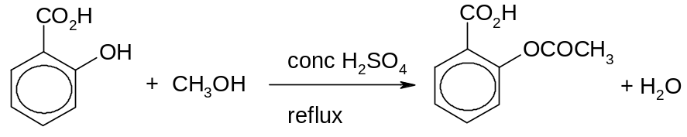

D
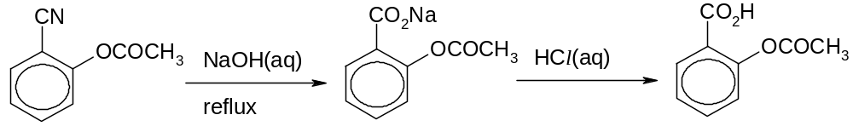

30 A useful oxidising agent specifically for vicinal diols (ie. the two OH groups are on adjacent carbons) used in the laboratory includes NaIO₄. An example of the conversion using butane-2,3-diol is shown below:
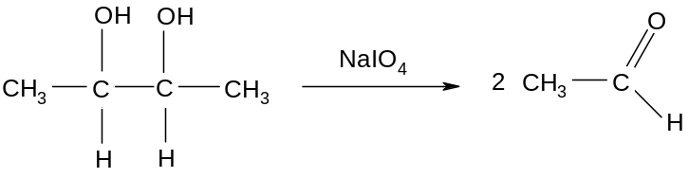

What would be the final organic products obtained when compound Y is first treated with cold alkaline aqueous KMnO₄ followed by NaIO₄?

Compound Y is CH₃CH=C(CH₃)–CH₂–CH=CH(CH₃)

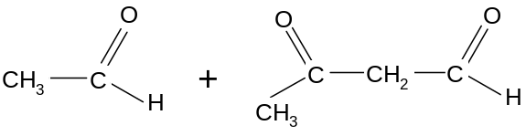

A

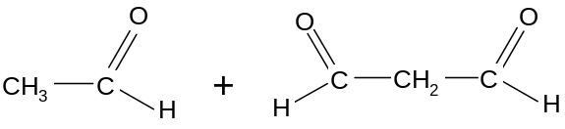

B

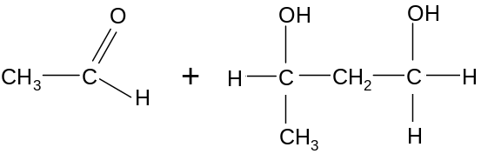

C

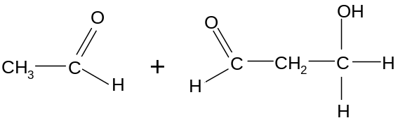

D

For each of the following questions, one or more of the three numbered statements 1 to 3 may be correct. Decide whether each of the statements is or is not correct. The responses A to D should be selected on the basis of:

A | B | C | D
1, 2 and 3 are correct | 1 and 2 only are correct | 2 and 3 only are correct | 1 only is correct

31 Gaseous particle X has a proton number n and a charge of +1.
Gaseous particle Y has a proton number of (n + 1) and is isoelectronic with X.

Which of the following statements correctly describe X and Y?

1 Y has a smaller radius than X.
2 Y requires less energy than X when a further electron is removed from each particle.
3 Y releases less energy than X when an electron is added to each particle.

32 The diagram below represents a circuit for electroplating copper, silver and gold in three separate cells in series.
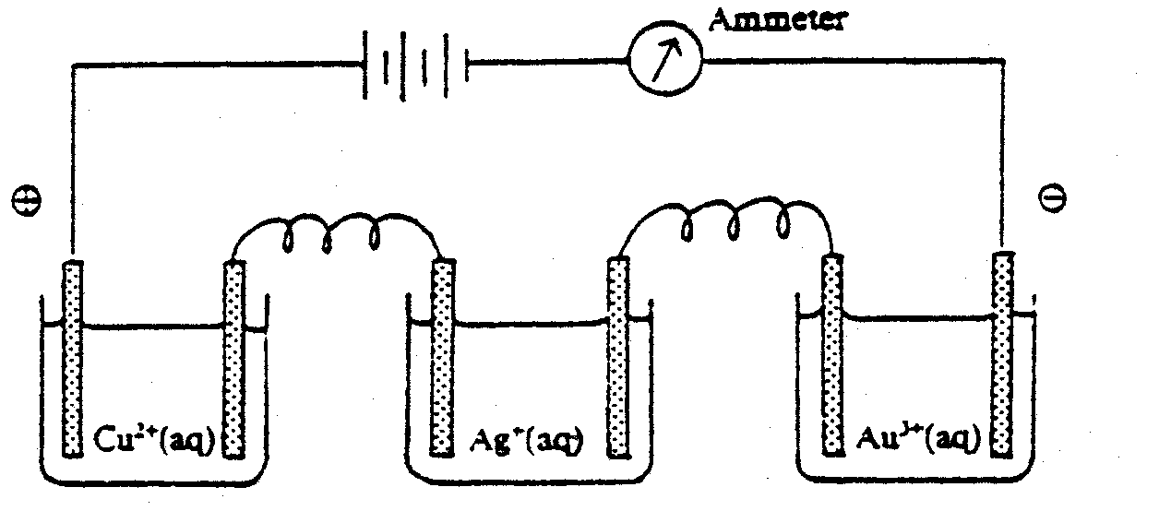

Cu²⁺(aq)
Ag⁺(aq)
Au³⁺(aq)

A current of 1 ampere flows through the circuit for 1 hour. Which of the following is true of the experiment?

1 The number of moles of each metal deposited in increasing order is, Au, Cu, Ag.
2 The mass of each metal deposited in increasing order is Cu, Au, Ag.
3 The amount of metal deposited will increase if the concentration of all three electrolytes is increased.

33 The Group II metals have higher melting points than the Group I metals. Which factors could contribute towards the higher melting points?

1 Two valence electrons are available from each Group II metal atom for bonding in the metallic lattice.
2 There are smaller interionic distances in the metallic lattices of the Group II metals.
3 Group II metals have higher first ionisation energies.

34 Which of the following statements about Group VII chemistry are correct?

1 The boiling point of hydrogen iodide is lower than that of hydrogen chloride.
2 Down the group, the reactivity of the halogens decreases when forming its hydride.
3 The reaction between iodide ion and concentrated sulfuric acid results in the oxidation state of sulfur decreasing from +6 to -2.

35 Use of Data Booklet is relevant for this question.

Which of the following statements is true about vanadium and its compound?

1 The maximum oxidation state of vanadium is found in the oxo-anion VO₂⁺.
2 Lead is able to reduce VO₂⁺ to V³⁺.
3 The density of vanadium is smaller than that of calcium.

36
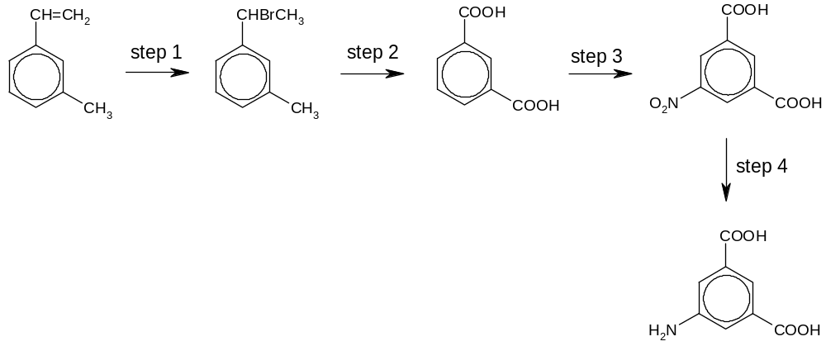
I
II
III
IV

Which type of reaction has taken place in the above reaction scheme?

1 electrophilic substitution
2 oxidation
3 reduction

37 Chloroethane can be formed from bromoethane in two steps.

Step 1
Step 2
CH₃CH₂Br CH₃CH₂OH CH₃CH₂Cl

Which statements about these steps are correct?

1 Step 1 involves a nucleophilic substitution.
2 Hot aqueous sodium hydroxide is the reagent in step 1.
3 Hot aqueous sodium chloride is the reagent in step 2.

- Benzoylglycine (hippuric acid) was first isolated from stallions’ urine.

CONHCH₂CO₂H

Which properties does this compound possess?

1 It can be hydrolysed to produce an amino acid.
2 It can be made by reacting benzoyl chloride, C₆H₅COCl with aminoethanoic acid, NH₂CH₂CO₂H.
3 It can be neutralised by reaction with cold aqueous sodium hydroxide.

39 Which of the following compounds form a single organic product when it is heated with acidified potassium manganate(VII) solution?

1 | 2 | 3
CH₃–CH₂–CH₂–CH=CH₂ | 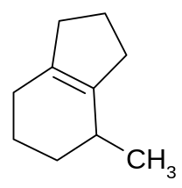 | 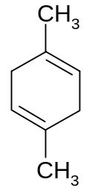

40 For the upcoming inaugural Youth Olympics Games (YOG) in Singapore, former Olympic winners will share their experiences with participating athletes in dealing with competition pressures and sport injuries.

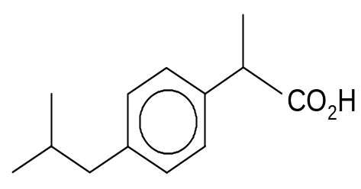
One common sport injury is muscle sprain. To reduce swelling and pain, ibuprofen is usually administered. The structure of ibuprofen is shown.
CH₃
CH₃
H₃C

Which of the following are expected to be true for ibuprofen?

1 On heating with hot acidified KMnO₄, the following is formed:
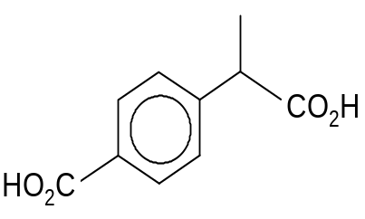
CH₃

2 It has very low solubility in water.

3 It can be reduced by LiAlH₄.

